THE SWISS INTERNATIONAL
SCIENTIFIC SCHOOL OF DUBAI

ASSESSMENT

ENTRANCE INTO GRADE 9

Time: 1 hour

No Calculator

Name: ____________________

Date: _____________________

No calculator

Just try your best. Try to answer all the questions to the best of your ability.

- Calculate the following

a.
$$-3+6=$$
b.
$$8-6=$$
c.
$$-4--8=$$

- Calculate the following and show your work.
a.
$$\frac{156}{4}=$$

b.
$$3×3+8÷4=$$

c.
$$3 ×\left(\sqrt{49}+6 (2-1)\right)=$$

d.
$$15+{2 }^{2}×\left(8-6\right)=$$

- Calculate the following:

a.
$$\frac{4}{5}×\frac{3}{5}=$$

b.
$$2\frac{2}{3}+\frac{1}{4}=$$

c.
$$4×1\frac{3}{5}=$$

- Kareem got 13 out of 25 questions on his math test correctly. What is his percentage mark?

- If you have $0.30 in 5 cents and $0.70 in 10 cents, how many coins do you have?

- If $x= -3$what is the value $3x-4$?

- Simplify:

$$7(x+4)$$

- What is the simplified algebraic expression for the perimeter of the rectangle?

- What is the algebraic expression for that represents this sequence?

(Let x represent the term number.)

7, 11, 15, 19…….

- A fishing permit costs $15. Each hour of fishing costs $3.

h : number of hours fishing
C : total cost

Write the rule as an algebraic equation for this relation.

- Simplify:

$$-5a^{2}+7-2a-8a^{2}$$

- Find the mean (moyenne, durchschnittlich) for the following data.

2, 4, 7, 4, 3, 12, 24

Mean:

- Find the Surface area of the following 3D shape.

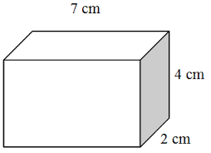

- What is the length of the hypotenuse?

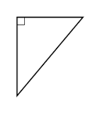
8 cm

6 cm

- Find the Volume of the following 3D shape.

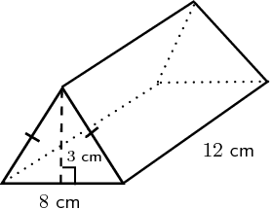

120 mm

- Find the probability of rolling a 2 or a 3 on a 6 sided dice.

